Toronto neighborhood analysis for an Indian family to live in

**Project:** IBMData Science Professional Certificate Program – Capstone Project

**Author:** Indrajeet Subhash Bhuskute

**Version**: 1.0

**Contents**:

1. Introduction 2

2. Problem Statement 2

3. Data acquisition and preparation 3

4. Methodology 5

5. Results 10

6. Discussion 13

7. Conclusion 13

8. References 14

# 1. Introduction

**City of Toronto** is the most populous city in Canada. It is home to various ethnic groups such as Canadian, English, Chinese, Indian, Italian etc. It is recognized as one of the most multicultural and cosmopolitan cities in the world.

Toronto is an international center of business, finance and culture. The business and employment opportunities in Toronto lead to temporary or permanent immigration of many families. There is also a lot of internal migration from within Canada to Toronto. Reasons can be economic, arts, better standard of living, etc.

Migrating to a new city is not a simple task. One has to consider multiple facets while choosing a neighborhood to settle ex: Proximity to schools, colleges, hospitals, banks, hotels, etc. These are some of the basic important factors which a person should consider whenever he/she tries to relocate to a new city.

In this report, we will focus on Indian families that are planning to move to the great city of Toronto.

# 2. Problem Statement

Enable an Indian family to select a neighborhood to relocate in the city of Toronto.

# 3. Data acquisition and preparation

### 3. A

We need to identify all the neighborhoods in the city of Toronto. Neighborhood details according to postal codes are available on the following wiki page <https://en.wikipedia.org/w/index.php?title=List_of_postal_codes_of_Canada:_M&oldid=945633050>.  
Some postal codes may not have any neighborhoods within them or sometimes multiple neighborhoods will have the same postal code. We have removed the entries having no neighborhoods and also combined multiple neighborhoods for a single postal code.

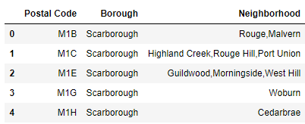

### 3. B

We need to identify coordinates of each neighborhood. These are available at: <http://cocl.us/Geospatial_data>. This is a csv file that has the geographical coordinates of each postal code of Toronto. We will combine the neighborhoods with geographical coordinates using Postal Code.

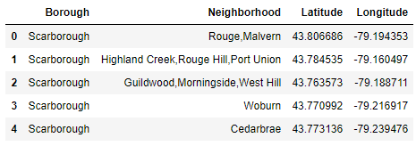

### 3. C

We need to identify important elements of each neighborhood such as schools, hospitals, parks etc. Since we are focusing on Indian family, it will be great if we could identify Hotels serving Indian food as well. This information can be accessed using third party Foursquare APIs.

**Foursquare** is a social location service that allows users to explore the world around them. Based on latitude and longitude, it will provide nearby services such as hotels, banks, stores, specific type of restaurants etc.

For each neighborhood identify the venues based on following categories: School, College & University, Bank, Hospital, Indian Restaurant, Grocery Store, Supermarket, Shopping Mall and Pharmacy

Foursquare provides category ids for each venue category. These are available in their developer docs (<https://developer.foursquare.com/docs/build-with-foursquare/categories/>). Foursquare service returns accurate results when specified with correct category Ids. Following are the ids for our selected categories:

* 4f4533804b9074f6e4fb0105 - Elementary school
* 4bf58dd8d48988d13d941735 - High school
* 4f4533814b9074f6e4fb0106 - Middle school
* 4f4533814b9074f6e4fb0107 - Nursery school
* 4bf58dd8d48988d10a951735 - Bank
* 4bf58dd8d48988d196941735 - Hospital
* 4bf58dd8d48988d10f941735 - Indian Restaurant
* 4bf58dd8d48988d118951735 - Grocery Store
* 52f2ab2ebcbc57f1066b8b46 - Supermarket
* 4bf58dd8d48988d10f951735 - Pharmacy

We have explored the neighborhoods using Foursquare services and searched for venues that belong to our category list within a radius of 1000 meters. Foursquare returns all the venues for the categories we have specified as well all the venues in their sub categories. We have merged such sub category results into a common label/category. Example: "Indian Restaurant", "South Indian Restaurant", "North Indian Restaurant" and "Indian Chinese Restaurant" can be given a common label **as "Indian Restaurant"**

We have updated categories to common labels. We have the following counts:

* Medical Center 726
* Bank 660
* Food store 511
* School 374
* Indian Restaurant 280
* Supermarket 108

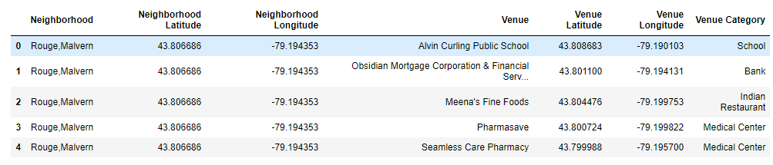

Using One Hot Encoding on Venue Category, categorical values are converted into columns and the venues are marked under appropriate category columns. I have also combined the values of categories for each neighborhood**. Since we are doing this study for an Indian family, we will not consider the neighborhoods with zero Indian Restaurants**.

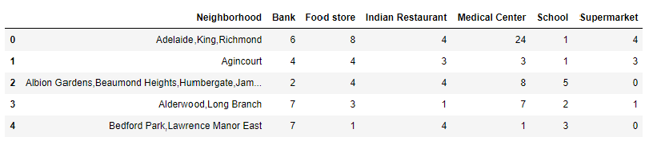

# 4. Methodology

**Let's visualize our neighborhoods for top 20 venues per category**

* Neighborhoods vs. Indian Restaurants

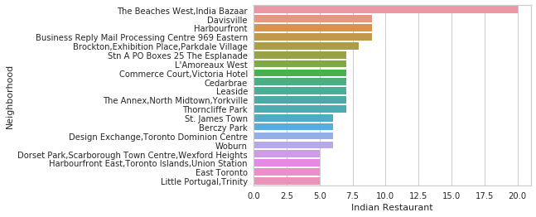

* Neighborhoods vs. Medical Centres

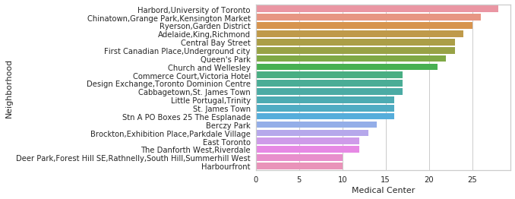

* Neighborhoods vs. Food stores

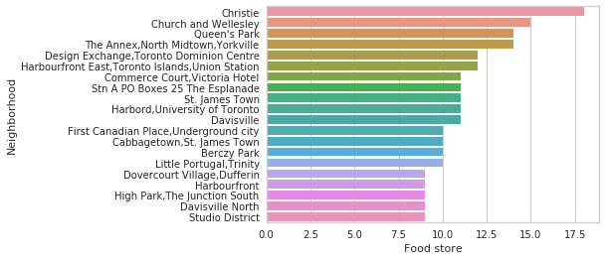

* Neighborhoods vs. Banks

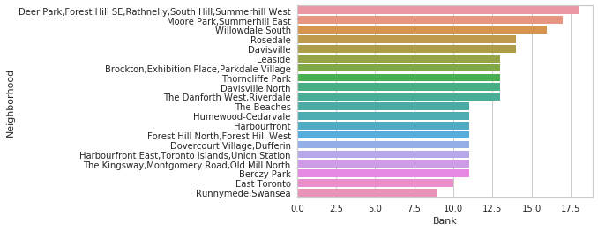

* Neighborhoods vs. Supermarkets

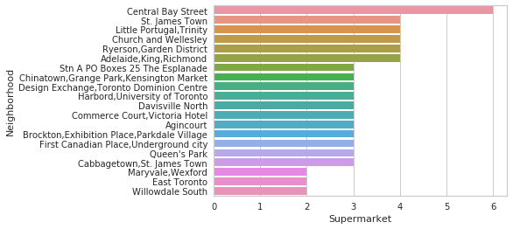

* Neighborhoods vs. Schools

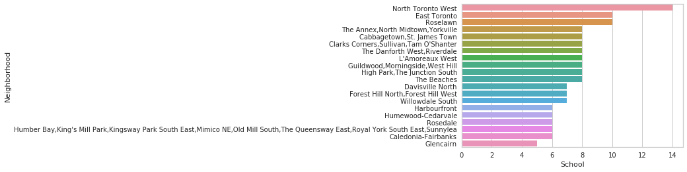

**Inference from visualizing data**

As it is visible from the graphs above, the venue categories are not evenly spread across the neighborhoods. Some neighborhoods which have high number of medical centers do not have enough schools. So, we cannot say that a particular neighborhood is good for living based on only one category.

Using the essential venue categories, we can divide the neighborhoods into different segments. For this, we would need to calculate **livability score** for each neighborhood.

**Define "Livability Score" for neighborhoods**

Livability is the sum of the factors that add up to a community's quality of life. Livability score can be calculated using **"Weighted Average"** formula. Weighted average takes into account the variation in importance of the variables in a data set. In calculating a weighted average, each variable value in the data set is multiplied by a predetermined weight.

Following is the distribution on weights (out of total 100) given to each category:

* Indian Restaurant - 30
* School - 20
* Food store - 20
* Supermarket - 15
* Medical Center - 10
* Bank - 5

With comparison to other categories, Food is something that has uniqueness to each culture. **Indian Restaurants are given the highest weight** as it signifies the neighborhood's closeness to the Indian community. While the Banks have been given the least weight as they are not an everyday necessity.

This Livability score will help an individual make a decision on which neighborhood to select. We calculated the Livability score for each neighborhood and sorted the neighborhoods according to the score.

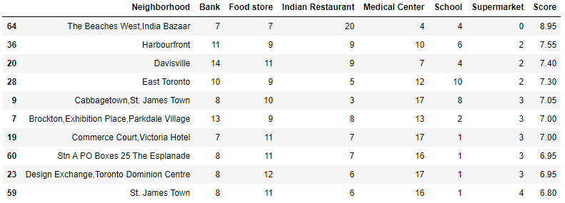

**Create cluster of neighborhoods**

Now we have the scores of each neighborhood, it would be useful to group similar neighborhoods together. Based on their scores, we need to segment the neighborhoods into groups. We can do this using **K-Means clustering algorithm**.

Before we segment the neighborhoods, we need to identify how many groups can be created from the given data. To achieve this, we used the **Elbow Method**.  
The Elbow Method is a heuristic method of interpretation and validation of consistency within cluster analysis designed to help find the appropriate number of clusters in a dataset.

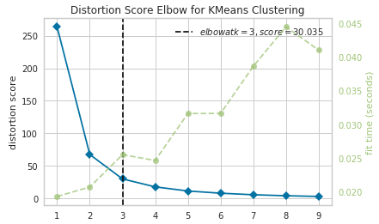

From the Elbow Method, we understand that we should segment the neighborhoods in to **3 clusters: Good, Moderate and Poor.**

**Using cluster size as 3, we applied K-Means clustering algorithm to our data and generated groups for them. The labels for the group are 0, 1 and 2. Note that 0, 1 and 2 are not scores and they do not mean poor, moderate and good. These are just the group numbers into which the neighborhoods are segmented**

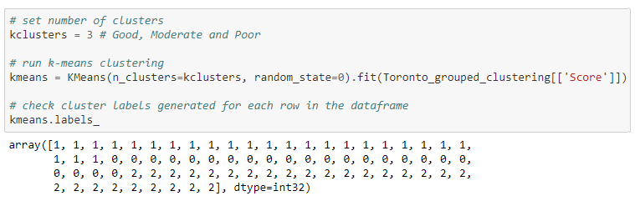

We will assign these cluster labels to our processed data set

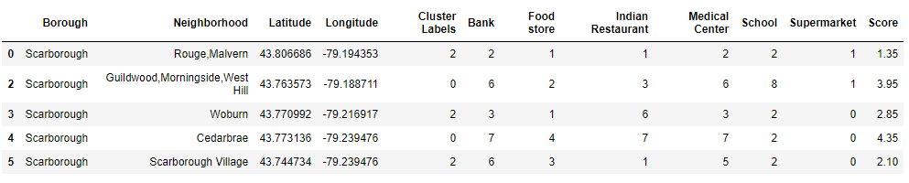

**Visualize the clusters of Toronto neighborhoods**

To visualize the neighborhoods, we will use Folium map library. We will render the map of Toronto and using the coordinates of each neighborhood, we will highlight them on the map as a circle. Each circle will represent a neighborhood and neighborhoods belonging to same cluster will have the same color.

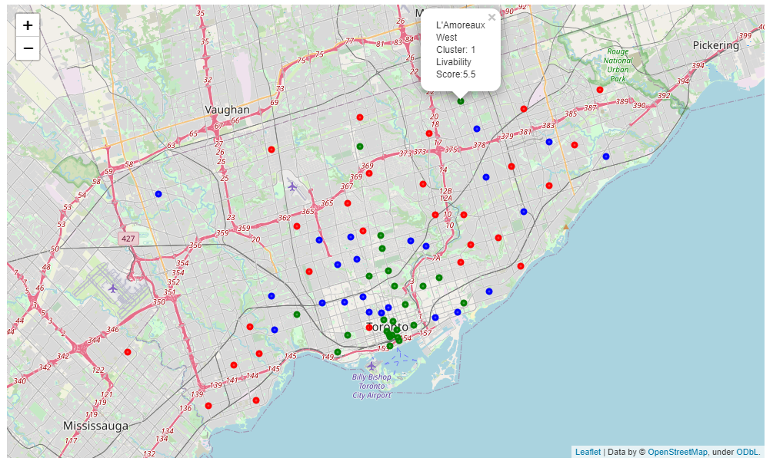

# 5. Results

### ****5.1.****

In this project, we have identified livability score for different neighborhoods according to need/necessity of an Indian family.

#### 5.1.a) Top 5 neighborhoods identified for an Indian Family

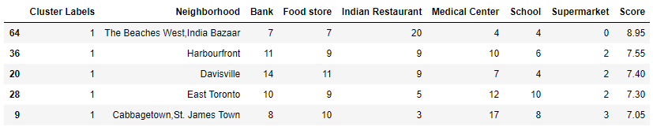

#### 5.1.b) Distribution of Scores against Indian Restaurants

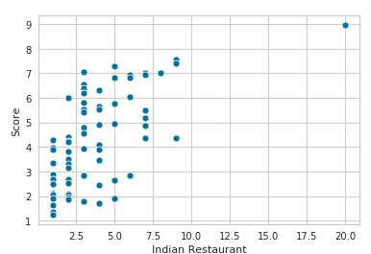

5.2.

We have also identified similar neighborhoods and segmented them into 3 categories: **Good, Moderate and Poor**.

#### 5.2.a) Cluster 1 contains all neighborhoods that fall into "Good" category



#### 5.2.b) Cluster 0 contains all neighborhoods that fall into "Moderate" category



#### 5.2.c) Cluster 2 contains all neighborhoods that fall into "Poor" category



# 6. Discussion

Typically, any neighborhood which has a good number of food outlets that specialize in a particular cuisine have association with a particular community.  
As clearly seen from the result **#5.1.a**, Neighborhoods having high number of Indian Restaurants are ranked higher.

However, having a high number of Indian Restaurants is **not the only factor contributing to the livability score** of the neighborhood. This can be clearly seen from the graph in result **#5.1.b**, where neighborhoods have a high score even with low number of Indian Restaurants  
let us compare the **'Woburn'** neighborhood which falls in the Poor category with **'Willowdale South'** neighborhood that falls in the Good category:

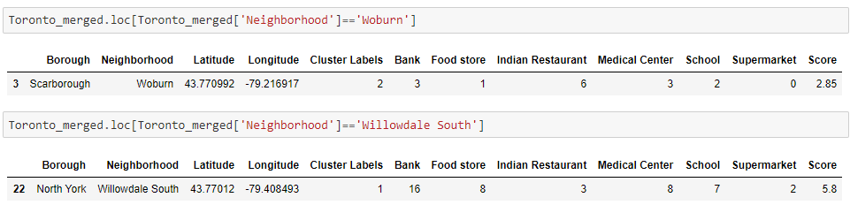

As clearly observed from the comparison, Even though ‘Woburn’ neighborhood has double the number of Indian restaurants as 'Willowdale South', its score is far less. This is because of other important factors such as Food store, Medical Centers and Schools that contribute to **quality living**. In our process of calculating livability score, we have given appropriate weights to each venue categories and our results have correctly reflected it.

# 7. Conclusion

Whenever any individual or family wants to relocate to another city, they have to consider multiple factors to select a neighborhood to live in. In this report, **we have considered most essential factors that contribute to a neighborhood's quality of life. Factors such as Food stores, Medical Centers, Schools, Supermarkets, banks are good candidates**. Since we are focusing on an Indian family, we have considered **Indian Restaurants** as one of the essential factors and it carries more weight than other factors.

We started off with collecting postal codes of each neighborhood, their coordinates and the essential venues in each neighborhood. We filtered out the unwanted venues and only processed those venues that belong to essential selected categories. We calculated the **Livability Score** of each neighborhood using these essential categories and found out the top neighborhoods that an Indian family can consider settling. We applied machine learning technique called K-Means clustering algorithm to segment the neighborhoods into 3 groups: **Good, Moderate and Poor**.

By identifying Livability Scores and clusters of similar neighborhoods, we have equipped the reader of this report with analysis and comparison of different neighborhoods and help him make an informed decision.

# 8. References

* Wiki for Toronto Neighborhood data : <https://en.wikipedia.org/w/index.php?title=List_of_postal_codes_of_Canada:_M&oldid=945633050>
* Geo coordinates for Toronto Postal codes : <http://cocl.us/Geospatial_data>
* Pandas library : <https://pandas.pydata.org/>
* Sklearn for machine learning algorithms : <https://scikit-learn.org/stable/>
* Foursquare location service : <https://foursquare.com/>
* Folium for maps : <https://python-visualization.github.io/folium/>
* Numpy for scientic computing : <https://numpy.org/>
* Seaborn for statistical vizualization : <https://seaborn.pydata.org/>